Customer Segmentation & Churn Pattern Analytics
in European Banking

Internship Project Report

Submitted by:
Manisha Karmakar

Program:
B. Tech (CSE - AIML)

Institution:
VIT Bhopal University

Internship Organization:
Unified Mentor

Date of Submission:
28-04-26
Internship Overview
During this internship, I worked on analyzing customer churn in the banking sector using data analytics and machine learning techniques.
The objective was to identify customer segments with high churn risk and develop an interactive dashboard for visualization and decision-making.
The project involved data preprocessing, segmentation, exploratory analysis, model building, and dashboard development using Streamlit.
Tools and Technologies Used
• Python
• Pandas & NumPy
• Matplotlib & Seaborn
• Scikit-learn (Machine Learning)
• Streamlit (Dashboard Development)
• Jupyter Notebook
Customer Segmentation & Churn Pattern Analytics in European Banking

1. Abstract
Customer churn is a major challenge in the banking sector, directly impacting revenue and customer lifetime value. This project analyzes churn patterns using customer segmentation and machine learning techniques. By leveraging a dataset of 10,000 European banking customers, the study identifies high-risk segments and builds a predictive model to estimate churn probability. An interactive Streamlit dashboard is developed to visualize insights and enable real-time decision-making.

2. Introduction
Customer retention is critical for financial institutions as acquiring new customers is significantly more expensive than retaining existing ones. Churn leads to:
- Loss of revenue
- Increased acquisition costs
- Reduced customer lifetime value
Despite having rich datasets, banks often fail to extract actionable insights. This project aims to bridge that gap by combining segmentation analytics with machine learning.

3. Problem Statement
Banks struggle to:
- Identify high-risk customer segments
- Understand churn behavior across demographics
- Quantify financial impact of churn
This project addresses these issues through structured data analysis and predictive modeling.

4. Objectives
Primary Objectives
- Measure overall churn rate
- Analyze churn across customer segments
- Compare churn behavior across countries
Secondary Objectives
- Identify high-value customer churn
- Analyze engagement patterns
- Build a churn prediction model

5. Dataset Description
The dataset contains ~10,000 customer records with attributes:
- CustomerId
- CreditScore
- Geography (France, Spain, Germany)
- Gender
- Age
- Tenure
- Balance
- NumOfProducts
- HasCrCard
- IsActiveMember
- EstimatedSalary
- Exited (Target Variable)
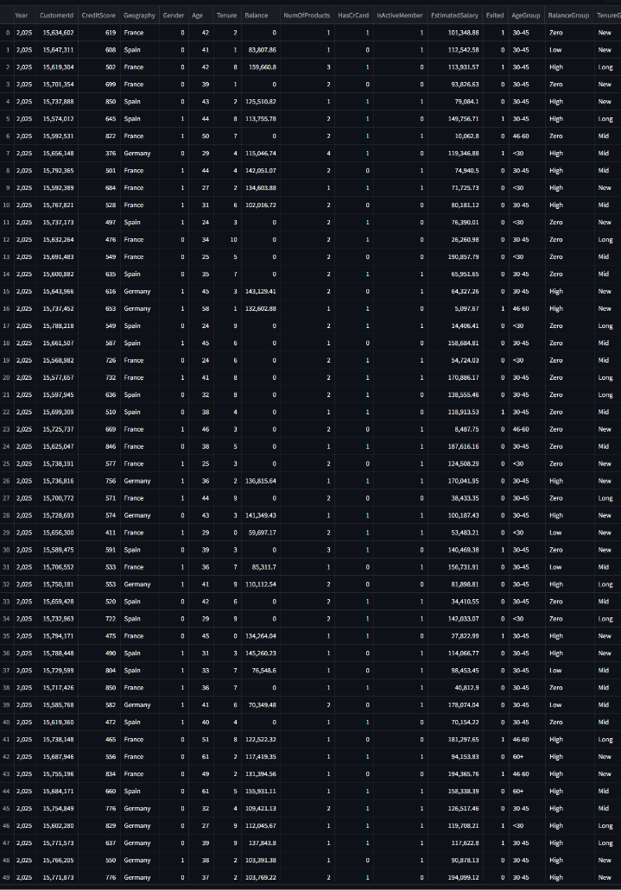
6. Methodology
6.1 Data Cleaning
- Removed irrelevant columns (Surname)
- Converted categorical variables into numerical format
- Checked for missing and inconsistent values
6.2 Feature Engineering
Customers were segmented based on:
- Age Groups: <30, 30–45, 46–60, 60+
- Balance Groups: Zero, Low, High
- Tenure Groups: New, Mid, Long-term
6.3 Exploratory Data Analysis
- Churn distribution across geography
- Age vs churn analysis
- Balance vs churn relationship
- Active vs inactive customer analysis
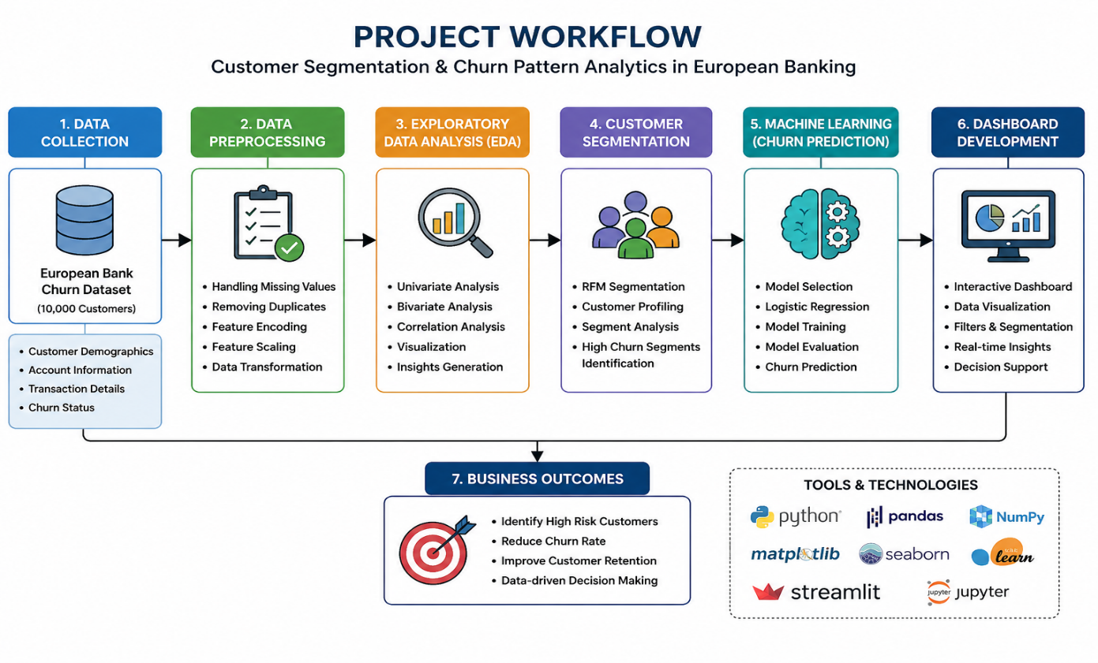
7. Machine Learning Model
A Logistic Regression model was implemented for churn prediction.
Model Details:
- Features used:
  - Credit Score
  - Age
  - Tenure
  - Balance
  - Number of Products
  - Credit Card status
  - Activity status
  - Estimated Salary
  - Gender
- Data split:
  - 80% training
  - 20% testing
- Data preprocessing:
  - Standard scaling applied

Model Functionality
The model predicts:
- Whether a customer will churn
- Probability of churn (%)
The model is integrated into the dashboard for real-time predictions.
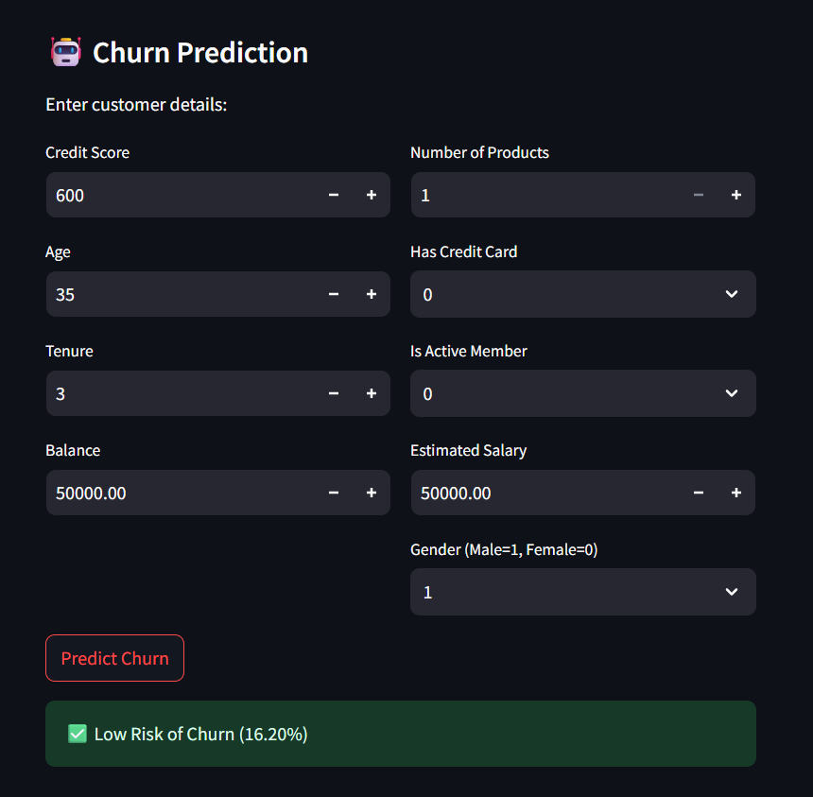
The above interface allows real-time prediction of customer churn based on input features. The model outputs churn probability and risk classification.
8. Key Insights
8.1 Geography
- Germany shows the highest churn rate
- France has the lowest churn rate

8.2 Age
- Churn increases with age
- Customers above 60 are most likely to churn

8.3 Financial Behavior
- High-balance customers also show churn risk
- This represents high revenue loss

8.4 Engagement
- Inactive customers have significantly higher churn
- Activity is the strongest churn indicator

9. Dashboard Implementation
An interactive dashboard was developed using Streamlit.
Features:
- KPI display (Churn rate, balance, customers)
- Filters (Geography, Age group)
- Visualizations:
  - Geography vs churn
  - Age vs churn
  - Balance vs churn
  - Activity vs churn
ML Integration
- User input form
- Real-time churn prediction
- Risk classification:
  - High Risk
  - Low Risk
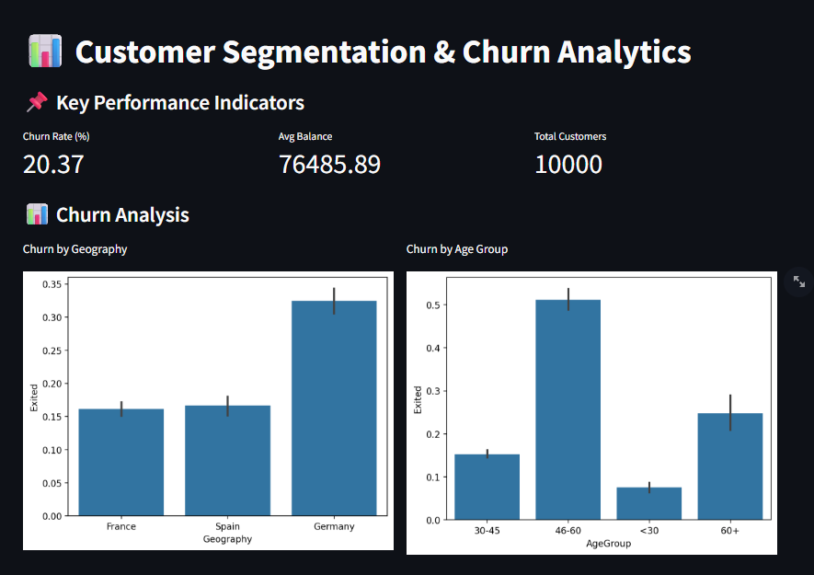
10. Results
- Clear segmentation of high-risk customers
- Identification of key churn drivers
- Successful implementation of predictive model
- Interactive visualization for decision-making

11. Business Recommendations
- Target high-value customers with retention strategies
- Improve engagement for inactive users
- Focus on high-churn regions (Germany)
- Offer personalized services for older customers

12. Future Scope
- Advanced ML models (Random Forest, XGBoost)
- Real-time data integration
- Customer behavior tracking
- Deployment with enterprise systems

13. Conclusion
This project demonstrates how segmentation and machine learning can effectively identify churn patterns in banking. By combining analytics with an interactive dashboard, the system provides actionable insights that can significantly improve customer retention strategies.

